

THE UNITED REPUBLIC OF TANZANIA

PRESIDENT’S OFFICE
REGIONAL ADMINISTRATION AND LOCAL GOVERNMENT

MBOZI DISTRICT COUNCIL FORM TWO MOCK ASSESSMENT
012 HISTORY

TIME: 2:30 Hours YEAR. 2023

Instructions
- This paper consists of sections A, B and C with a total of ten (10) questions.
- Answer all questions in the space provided.
- Section A and C carries fifteen (15) marks while section B carries seventy (70) marks.

SECTION A (15 MARKS)
Answer all questions in this section
- For each of the items (i) - (x), choose the correct answer from among the given alternatives and write its letter beside the item number in the table provided.
  - The people whose work is to study and explain remains which show man’s physical development and the tools he made used are called.

    - Iron smiths
    - Revolutionist
  - One of the factors for the fall of Songhai empire was
    - Invasion from Moroccans
    - Attacks from the Tuaregs
    - Evolutionist
    - Archaeologist

C. Attacks from the almoravids
D. Introduction of legitima
  - A process by which people from one community come to contact with one another is called:

    - Communication
    - Intention
    - Interaction
    - Union

  - The mode of production in which the major means of production were owned and shared by all the members of particular society was:

    - Feudalism
    - Slavery
    - Communalism
    - Communism

  - The Portuguese ………. was the first merchant’s explorer to go round the Africa cape in 1498.

    - Jan van Riebeek
    - Vasco Da Gama
    - Sir Francis Drake
    - Bartholomew

  - One of the problems of written records as a source of historical information is that they
    - Are given by elders C. Can be used by literate people only
    - Are mostly reliable D. Serve as store of variety information
  - Among the Makonde and Mwera tribes, the husband was supposed to move to the wife’s family and children belonged to mother’s side and children belonged to mother’s side. Which type of social organization was used?

    - Kinship organization
    - Clan organization
    - Matrilineal organization
    - Patrilineal organization

  - The economic factors for interactions among the people of Africa during the pre-colonial era were?
    - Immigration, intermarriage and language
    - Need of new land, trade and agriculture
    - Trade, intermarriage and language
    - War, trade and migratio
- The introduction of circuit court system at the cape of good hope was not only a reason for the Boers exodus, what do you think was other reasons?
    - The Boers good relationships with the Xhosa
    - Willingness of the Boers themselves
    - The cape had no conducive environment for the Boers to settle
    - Introduction of English language as official language at the cape
- Why did the European counties demand material from Africa during the 19th Century?
    - The European raw materials were insufficient
    - The European countries wanted to develop Africa
    - The European had enough raw materials
    - The Africans did not need their raw materials
- March the year in List A with the corresponding historical facts in list B by writing the letter of the correct response below the item number in the table provided.
LIST A | LIST B
(i) 1652  (ii) 1867  (iii) 1886  (iv) 1698  (v) 1840 | - Fall of fort Jesus  - The death of Zwangendaba  - Dutch East India company established the first Dutch settlement at the cape  - Seyyid Said shifted his capital from Oman to Zanzibar  - Kaffir wars  - Diamond was discovered at Kimberlye in the orange free state  - Vasco Dar Gama successfully reached India after going round the cape of South Africa  - Gold was discovered in Witwatersrand in Transvaal

- Briefly explain the following terms
  - Kaffir wars
  - Boer Trek
  - Ngoni Migration
  - Mfecane
  - Monsoon winds

SECTION B (70 Marks)

Answer all questions in this section
- Re-arrange the following sentences in chronological order by writing their roman numbers in the table below.
- It started with the discovery of America by Christopher Columbus as he was on his way to India in 1492
- After great exploration of America Christopher Columbus called it, the new world
- The economic potentiality of America attracted Europeans such as Spanish, Portuguese,
- British and French
- Triangular slave trade can be traced as far back as during journeys of discoveries
- He managed to go back to Europe where by he convinced many European to form plantations and mines
- Briefly answer each of the following questions
How the discovery of fire during the middle stone age changed man’s life (Give two reasons)
  - How the discovery of fire during the middle stone age changed man’s life (Give two reasons)
  - The Ngoni succeeded in defeating other communities because of using the “Cow horn” technique. How was this technique applied?
  - Why Boers moved from the cape to the North and North Eastern part of South Africa? Give two reasons
  - How Iron tools changed the lives of human being? Give two reasons
  - Mwakifulefule preferred reading various documents in order to get several historical information. Explain the limitations of such kind of sources. (Give two reasons)
- Differentiate the following
  - Archives and Museums
  - Sedentary pastoralists and Nomadic pastoralists
  - Local trade and Regional trade
  - State and Centralized states
  - Objects of labour and Instruments of labour
- Study the sketched map which shows trade routes during the 15th Century and then answer the questions which follows
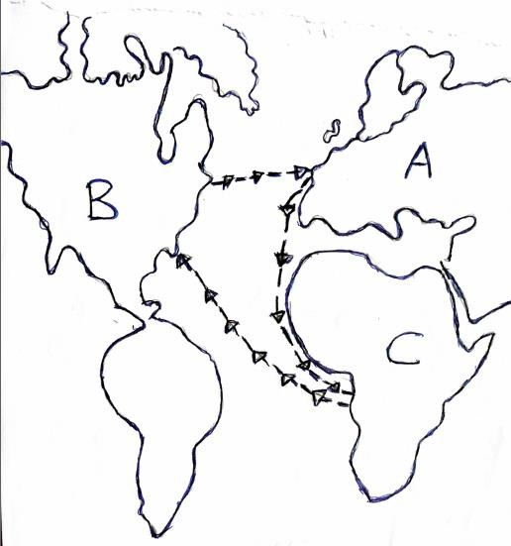

Questions
  - In the sketched map shown, which letter represents the Continent which was the source of labour?
  - Which letter represents the Continent whose natives were known as Red Indians?

  - Through which ocean was the trade conducted?

  - Which letter represents the Continents which specialized in production of manufactured good?
  - What is the name of the trade shown in the sketched map?

- Briefly describe five (5) causes of Mfecane war in South Africa

- Briefly explain five (5) reasons on how people become slaves in pre-colonial Africa

SECTION C (15 Marks)
- Explain five effects of the abolition of the slave trade on Africa

